**Science**

* Living things and their habitats

**Key Skills**

* explore and compare the difference between things that are living, dead, and things that have never been alive
* identify that most living things live in habitats to which they are suited and describe how different habitats provide the basic needs of different kinds of animals and plants, and how they depend on each other
* identify and name a variety of plants and animals in their habitats, including micro-habitats
* describe how animals obtain their food from plants and other animals, using the idea of a simple food chain, and identify and name different sources of food

**Special Events / Visits (COVID permitting)**

* Big Bird Watch Weekend
* Safer Internet Day

**English**

* Our key text is “The Dark” by Lemony Snicket. We will be writing a story based on this narrative, writing a fictional recount and compose poetry based on visual imagery.

**Key Skills**

* practise and refresh skills in reading comprehension,
* spelling, handwriting and writing composition; looking at the features of both fiction and non-fiction styles as well as poetry.
* expanding knowledge and understanding of punctuation marks and how they are used correctly.
* develop vocabulary by using adjectives to describe. (Year 2 – Expanded noun phrases/ adverbs)
* learn to use the terms noun, adjective, verb and adverb
* Use conjunctions to join sentences
* Year 2 - expanded noun phrases, powerful verbs and adverbs to add impact to writing.
* write using different sentence types e.g. commands, statements, exclamations and questions.
* refine the planning process when writing using both verbal and written planning processes
* begin to proof-read work to improve final piece

**History – Fantastic Firsts - Changes in Transport**

In this unit the children will learn about transport in the past, present and future. First, will learn about the Viking Longboat, then we will go on to learn about cars and how they have changed over time. Next, we will learn about George Stevenson and his inventions and finally we will learn about the Wright Brothers and their invention of the aeroplane. We will then compare these modes of transport and use a variety of sources of information to find out the information we need.

**Key Skills**

**Knowledge: Changes within living memory and beyond, similarities and differences between transport now and those in the past, key events in the lives of significant individuals and how they contributed to national achievements (George Stephenson)**

**Concepts: Historical Significance, Chronology, Continuity and Change**

**Skills: Creating a sequenced timeline, Chronology over a longer time frame, reading photographs and film**

**Mathematics**

• NUMBER: Place Value

• NUMBER: Multiplication and Division

**Key Skills**

Year 1:

* Count in multiples of 2, 5 and 10.
* Equal groups and arrays
* Doubling single digit numbers
* Solving one step multiplication and division problems

Year 2:

* Count in 2s, 5s, 3s and 10s.
* Recall multiplication and division facts for the 2, 3, 5 and 10 times tables
* Recognise odd and even numbers
* Recognise a multiplication can be done in any order but a division can’t
* Solve 1 and 2 step problems

**Art**

* Artist – Leonardo Da Vinci
* Genre – Drawing

**Key Skills**

**Skills:**

Experiment with line drawings and quick free style sketches.

Observational drawings of cogs, bolts, machinery using sketching pencils.

Use a variety of HB graded pencils to add depth, shade, to their sketching.

Adding detail to line drawings.

Each child will:

* Explore Leonardo Da Vinci’s work
* Explore his shading techniques
* Plan, create and evaluate a drawing using his invention sketches as inspiration.
* Then we will evaluate our work.

**Thankyou for your support**

**Curriculum Overview**

**Spring Term 1**

**Year 1/2**

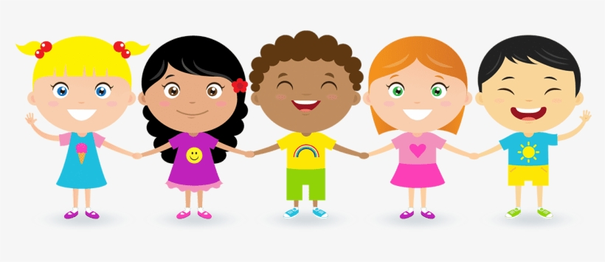

**Other**

**Key Skills**

* **Computing –** Animated story books and online safety
* **RE** – What is the good new Christians believe Jesus brings?
* **P.S.H.E.** –Year 1: what helps us to stay healthy? Year 2: what helps us to stay safe?
* **Music -** Ukulele Lessons and Charanga – I wanna play in the band
* **PE –** Unihock, yoga and Commando Joes