10th May 2019

Dear Year 3 parents and children,
Once again, thank you all very much for the hard work and time spent practising the times tables at home. As we approach the summer term and our third phase of times tables quizzes, it is even more important that the children should be able to readily recall multiplication facts. Please see dates below for this term.
This information is also available on the school website.
Friday 17th May | 3 x  TIPS:  Answers go odd, even, odd, even etc
Friday 24th May | 6 x  TIPS  - Double 3x table  - All answers are even
HALF TERM | Practice 11 x table at home
Friday 7th June | 9x  TIPS  Hold out hands with all fingers (and thumbs) stretched out in front of you.  1 x 9 (fold down first finger of left hand and you are left with 9 fingers) = 9  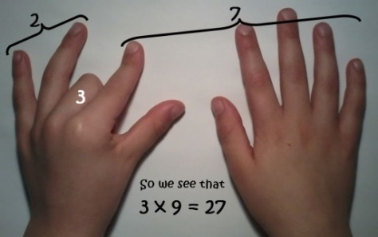  2 x 9 (fold down second finger leaving one finger to the left of the folded finger (this is the tens) and 8 fingers to the right of the folded finger (this is the units) = 18  3 x 9 ((fold down third finger leaving the two fingers to the left of the folded finger (this is the tens) and 7 to the right of the folded finger (this is the units) = 27
 | The digits of each multiple add up to 9.  1 + 8 = 9  2 + 7 = 9  3 + 6 = 9  Etc | Even 99  9 + 9 = 18 then 1 + 8 = 9  And 108  1 + 0 + 8 = 9
Friday 14th June | 4 x  - 4x is the same as doubling (multiplying by 2) then doubling again  - 7 x 4 = 28 (double 7 is 14, double 14 is 28)  All answers are even
Friday 21st June | 8 x table  - 8x is the same as doubling (multiplying by 2) then doubling again (x4) and then doubling again (x8)  - 7 x 8 = 56 (double 7 is 14, double 14 is 28, double 28 is 56)  - Double the 4 x table  - All answers are even
Friday 29th June | 7 x  Just have to learn it!
Friday 29th June | 11 x  - Spot the patterns, 11,22,33 etc  - Add 10 then 1
Friday 5th July | 12 x  - Spot the patterns in the units digit 12, 24,36,48,60  - Add 10 then 2
Friday 12th July | Maths Mashup

There are many fantastic games to practise times tables that are available on the internet/apps. If children log on to their School360 accounts >tools>J2E>J2Blast they will find activities to help them practise.

There are also some websites with timed multiplication tests. They can be found using the links below:
- https://collins.co.uk/pages/primary-mathematics-times-tables-test-simulator
If you go into the settings, you can change the tables and the time allowed.

From June 2020 there will be a statutory timed Multiplication Tables Check (MTC). Our current year 3 children will be the first to officially sit this online test next year – that gives us plenty of time for lots of regular practice at home and school.

I hope you find this information helpful. Please do not hesitate to come and see me if you have any questions.
Regards,

Janine Gray

