April 2018

Dear parents and children,
Once again, thank you all very much for the hard work and time spent practising the times tables at home. As we approach the summer term and our third phase of times tables quizzes, it is even more important that the children should be able to readily recall multiplication facts. Please see dates below for this term.
This information is also available on the school website.
Friday 27th April | 2 x  - If your child is very confident with this then I will be asking them to use their knowledge to answer the 20 x table using the same patterns observed in the 2 x table e.g.  3 x 2 = 6 ► 3 x 20 = 60
Friday 4th May | 5 x (50 x table for those children very confident with 5 x table)  TIPS:  - If it is an even number x 5 then the answer will have a 0 at the end  - If it is an odd number x 5 then the answer will have a 5 at the end
Friday 11th May | 3 x  TIPS:  Answers go odd, even, odd, even etc
Friday 18th May | 6 x  TIPS  - Double 3x table  - All answers are even
Friday 25th May | 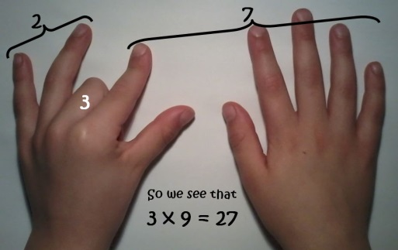  9x  TIPS  Hold out hands with all fingers (and thumbs) stretched out in front of you.  1 x 9 (fold down first finger of left hand and you are left with 9 fingers) = 9  2 x 9 (fold down second finger leaving one finger to the left of the folded finger (this is the tens) and 8 fingers to the right of the folded finger (this is the units) = 18  3 x 9 ((fold down third finger leaving the two fingers to the left of the folded finger (this is the tens) and 7 to the right of the folded finger (this is the units) = 27  The digits of each multiple add up to 9.  1 + 8 = 9  2 + 7 = 9  3 + 6 = 9  Etc  Even 99  9 + 9 = 18 then 1 + 8 = 9  And 108  1 + 0 + 8 = 9
HALF TERM | If you have time over half-term please could you work out how many weeks and days it is until we break up for the summer holidays! You might like to work out how many hours it is! And if you really want a challenge, how many minutes….!!
Friday 8th June | 4 x  TIPS:  - 4x is the same as doubling (multiplying by 2) then doubling again  - 7 x 4 = 28 (double 7 is 14, double 14 is 28)  All answers are even
Friday 15th June | 8 x table  TIPS:  - 8x is the same as doubling (multiplying by 2) then doubling again (x4) and then doubling again (x8)  - 7 x 8 = 56 (double 7 is 14, double 14 is 28, double 28 is 56)  - Double the 4 x table  - All answers are even
Friday 22nd June | 7 x  TIPS:  Just have to learn it!
Friday 29th June | 11 x  TIPS  - Spot the patterns, 11,22,33 etc  - Add 10 then 1
Friday 6th July | 12 x  TIPS  - Spot the patterns in the units digit 12, 24,36,48,60  - Add 10 then 2

There are many fantastic games to practise times tables that are available on the internet/apps. If children log on to their School360 accounts >tools>J2E>J2Blast they find activities to help them practise. I’ve also attached a few extra suggestions.

I hope you find this information helpful. Please do not hesitate to come and see me if you have any questions.
Regards,
Janine Gray

Dear Parents,
Confidence with times tables really is important for children in first school. Ensuring your child is confident with times tables you will be giving them some essential tools for success in maths. These tables top tips will provide some useful advice and great ideas to help you support your child in learning their times tables.
1. Get them familiar with multiplication concepts
The first step with multiplication is to make sure your child is familiar with what the numbers in multiplications really represent. Before they can cope with multiplication they need to be confident with sequences of numbers.
You can start when your child is quite young by practising counting in twos and threes, making number patterns and solving simple mathematical problems. Counting objects, making sets of similar objects and using blocks or LEGO (lots of ideas online) can all help to increase your child’s confidence with number bonds and multiplication facts.
2. Double your numbers
If your child learns how to double numbers this will help them to make connections between different times tables, for example the 2, 4, and 8 times tables.
3. Practise tables as a time-filler
When you’re sitting at traffic lights or waiting in the doctor’s surgery it is the perfect opportunity for a bit of times table practice! It’s always better (for both your child and you!) to just spend a few minutes reciting or testing times tables rather than going into overdrive and spending too long practising them.
4. Use the right vocabulary
Make sure you are using the right language to talk about multiplication.
Take a simple multiplication sum, such as 3 x 5 = 15. The 3 and the 5 are what we call factors of 15 and that 15 is a multiple of 3 and 5.
You can also demonstrate this by looking at the whole 3 times table written out in a list. Point out that each answer is a number that is a multiple of 3.
Finally, you can give your child a few sums to solve that use multiples of 3.
5. Help them with the ones they find tricky
There are usually one or two multiplication facts in each times table that are more difficult. When you notice that your child is stumbling over the same fact each time, try to give them extra practice. You could even get your child to write the fact out in a fun way on a piece of card and then stick it somewhere prominent (like on the fridge) so that they have an extra reminder!
6. Divide and conquer
As well as learning the times tables, your child should also know the division facts for each times table. (For example, if 3 times 5 is 15, 15 divided by 5 is 3, and 15 divided by 3 is 5.)
7. Make it real
The danger with too much rote learning of times tables is that children can fail to see the use of times tables in real life. Try to take opportunities to get your child to use multiplication in problem solving, for example working out quantities for scaling up a recipe, or calculating the price of more than one item of shopping.

8. Use a number grid
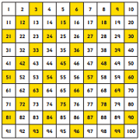
Printing off a simple 10 x 10 number grid can be a great way to demonstrate how times tables relate to number sequences. You can get your child to colour in multiples of different numbers on different number squares so that they can clearly see the number patterns.
9. Create a challenge
Make it fun by turning times table practice into a competition or challenge for your child, by timing them and keeping a record of their scores. You could even join in yourself and set a challenge to learn a more difficult times table, such as the 13 times table and get your child to test you at the end of the week in exchange for testing them…

