Name: Date:

**total marks**

leaf

roots

**Science Assessment Year 1:** Plants

1. 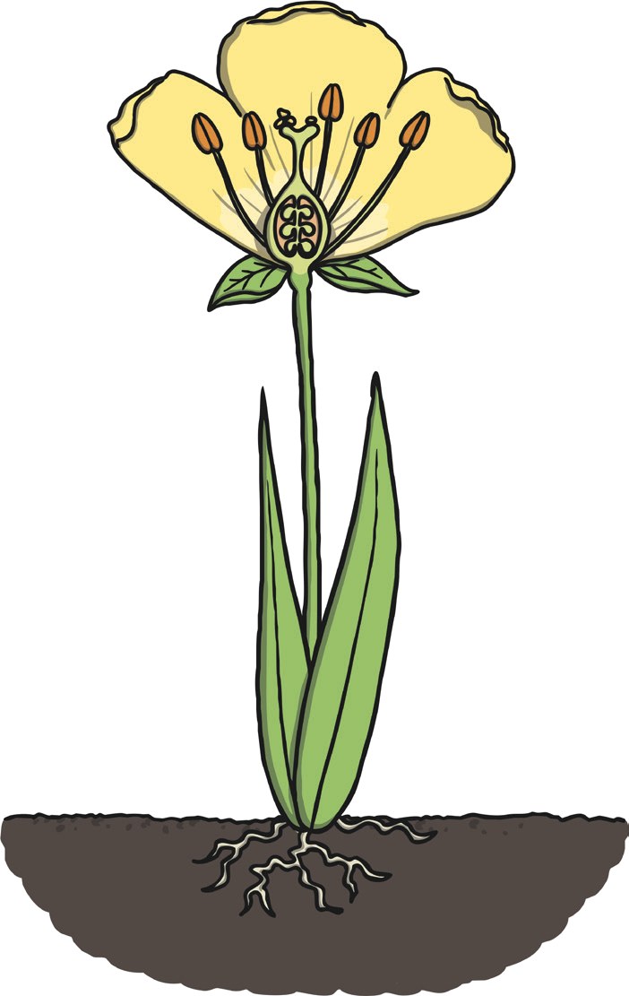Label the parts of the plant.

flower

**4**

1. Can you name any of these flowers?

stem

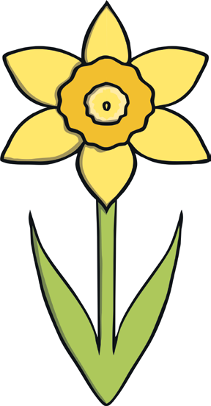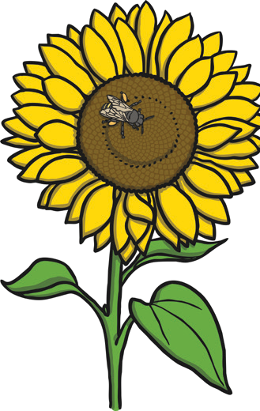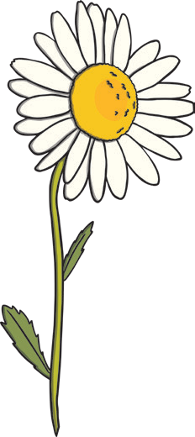

**4**

**Total for this page**

1. Sort these leaves into two groups.

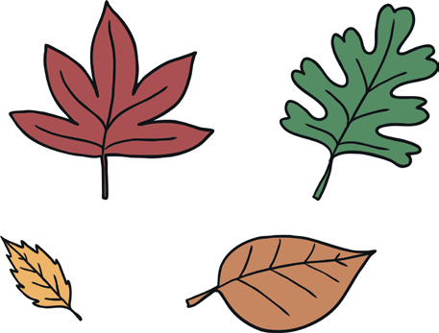

**1**

Why did you make the choice that you did?

**1**

1. For these foods, which part of the plant they come from is eaten?

|  |  |  |
| --- | --- | --- |
| **roots** | **stem** | **leaves** |
|  |  |  |
| **flower** | **fruit** | **seed** |
|  |  |  |

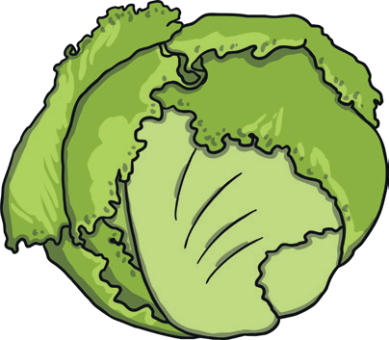

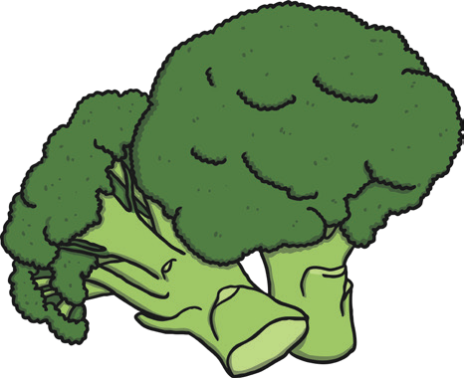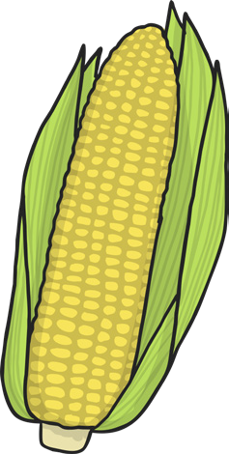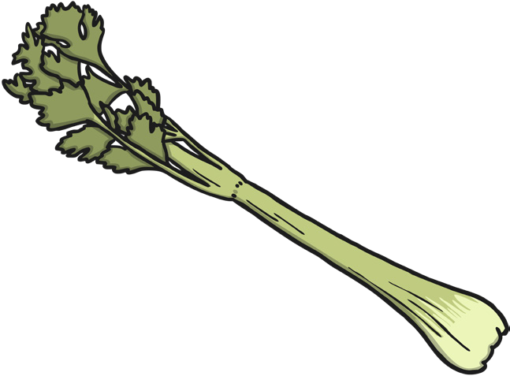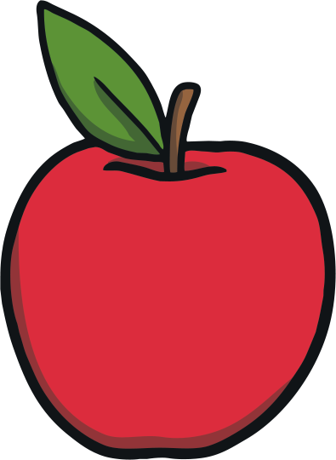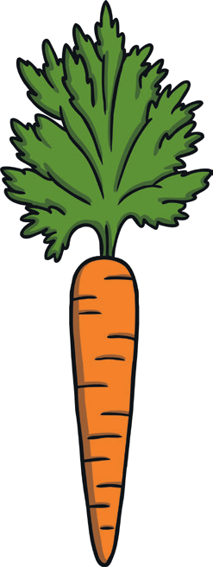

**5**

**Total for this page**

1. 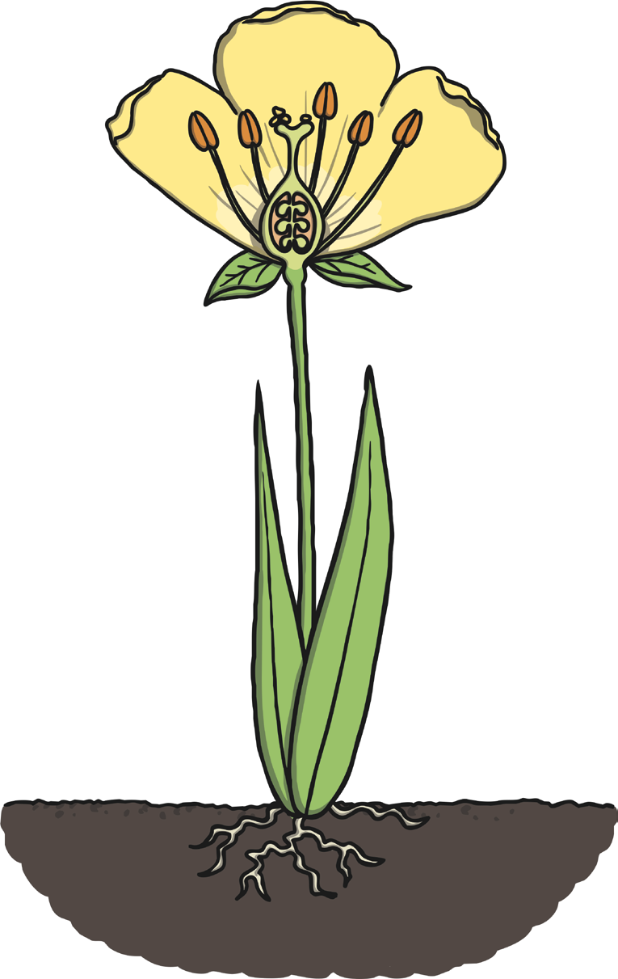Draw a line to match the parts of a plant with their job.

Helps to support the plant and carry water to different parts of the plant.

Takes in the water from the soil and keeps the plant in the ground.

Collects sunlight.

**3**

1. Which of these trees is evergreen?

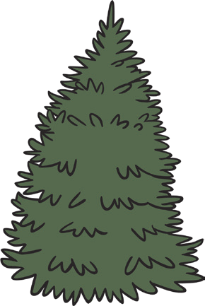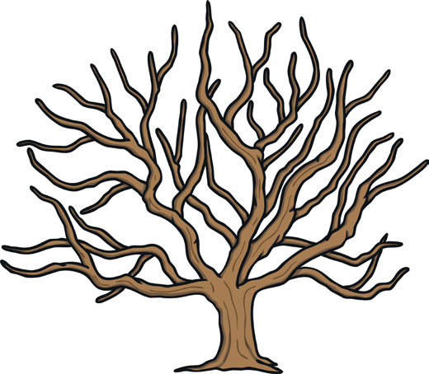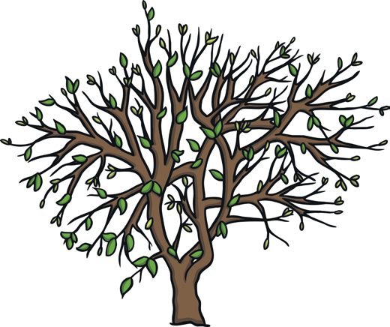

**1**

How do you know?

**1**

**Total for this page**

1. Circle the part of the plant that a bee is attracted to? stem flower roots leaves

**1**

1. 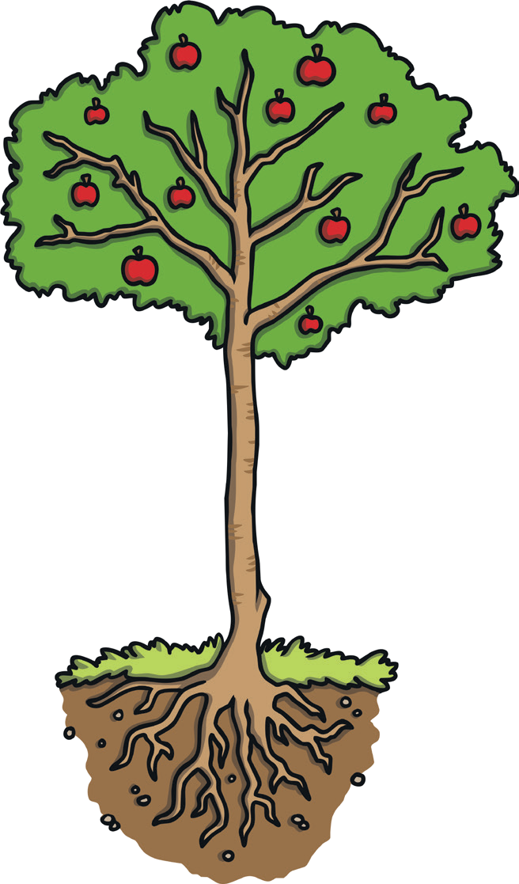Label the parts of a tree.

branch

fruit

leaf

**5**

1. What will this tree look like in winter? Draw it in the box.

root

trunk

**1**

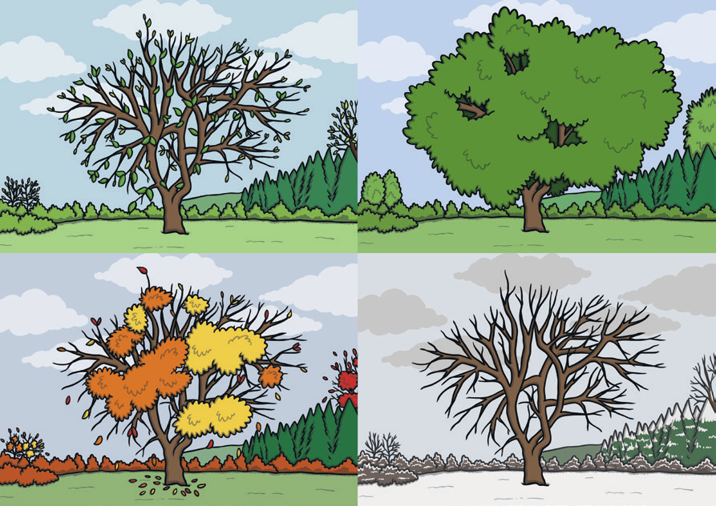

1. What does a plant need to survive? Write down two things.



**2**



**Total for this page**