Meet your Teacher
Me: 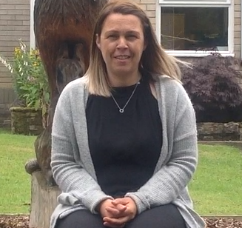
Hello,
Welcome to Reception Class
I’m Mrs Errington
Live: Stocksfield
Family: 3 children
Pets: Dog and Hens
My hobbies: Reading and sewing

Fact 1:
I worked at Broomhaugh School for 14 years!
A few of my favourite things
Colour: Purple
Food: Pasta
TV show: Sewing Bee
Animal: Dog
Sport: running
Fun Fact 2:
I really love shopping for clothes and shoes!
When I’m at school I like…….
Doing: Dressing up as different story characters
Watching: Auntie Mabel and Pippin
Playing: In the mud kitchen
Cooking: Apple crumble
Spending time with: All of the teachers and children in reception class!

