**Year 3/4 Optional Learning Menu**

Spring 2 2022

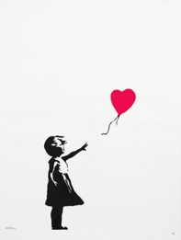

CREATIVE TASK – Choose a favourite European landmark e.g. Eiffel Tower.

Draw or create a 3D model of it. Write 3 facts about your chosen landmark too.

FOOD TECHNOLOGY – Seasonality and Culture

Create a recipe based on seasonal fruits or vegetables. It could be as simple as a fruit salad or smoothie! Or more adventurous for those budding chefs out there!

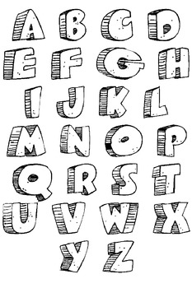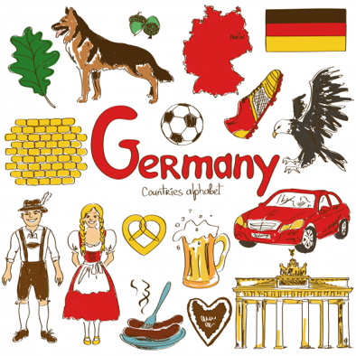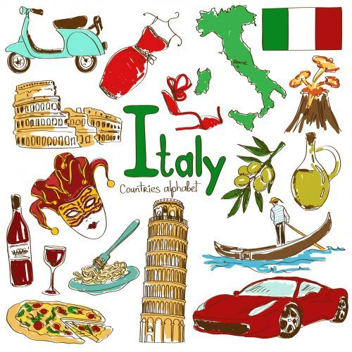

ART – Inspired by our focus artist, Banksy, can you write your name or key words (e.g. love, hello) in graffiti style letters?

MATHS – Revision

Use BUSY THINGS (School 360). Choose Y3/4 – MATHS then the addition/subtraction/multiplication/division area. Play the learning games here to revise all 4 skills.

**OUT AND ABOUT**:

* How do you feel about graffiti that you see when you are out walking or out in the car? It is against the law to graffiti public places without permission…in your opinion, are they artists or not? Take pictures and write a sentence explaining how you feel about it.

Choose a European country. Find out some of the well-known characteristics, landmarks, foods, cultural traditions etc. Create one of these fantastic CULTURE MAPS about you country. Here are 2 examples…

https://teachers.thenational.academy/lessons/what-are-the-countries-of-europe-69k6cr

Complete this online video lesson about countries in Europe. It will improve your knowledge ready for learning that you will do in school.