15th September 2017

Dear parents and children,
Please find below the dates and information for the times tables that you will need to practise at home. This information is also available on the school website. We would like the children to practise as often as possible aiming to beat their own personal record when they come to repeat that particular times table. As well as learning the multiplication facts it is also important to understand/begin to understand the corresponding division facts e.g 3 x 5 = 15 so… 15 ÷ 5 = 3
Friday 22rd September | 10 x table  TIPS:  - Each digit moves one place to the left as it gets ten times bigger and a 0 (called a place holder) is added to the units/ones
Friday 29th September | 5 x table  TIPS:  - If it is an even number x 5 then the answer will have a 0 at the end  - If it is an odd number x 5 then the answer will have a 5 at the end  - Multiply by 10 and then halve the answer
Friday 6th October | 2 x table  TIPS:  - 2x is the same as doubling  - All answers are even
Friday 13th October | 4 x table  TIPS:  - 4x is the same as doubling (multiplying by 2) then doubling again  - 7 x 4 = 28 (double 7 is 14, double 14 is 28)  - All answers are even
Friday 20st October | TEACHER TRAINING DAY – THIS TEST WILL BE SENT HOME TO COMPLETE  3x table  TIPS:  - Answers go odd, even, odd, even etc
HALF TERM | Over the holidays please learn/revise the number of days in each of the months of the year.  30 days has September,  April, June and November.  All the rest have 31  Except February alone,  Which has 28 days clear  And 29 in each leap year.  Or you can use the "knuckle method": A knuckle is "31 days", and in between each knuckle it isn't.  And where your hands meet, the two knuckles are "July, August", which both have 31 days.  (Note: the last knuckle isn't used)  Example: October is on a knuckles, so it has 31 days
Friday 3th November | 6 x  TIPS  - Double 3x table  - All answers are even
Friday 10th November | 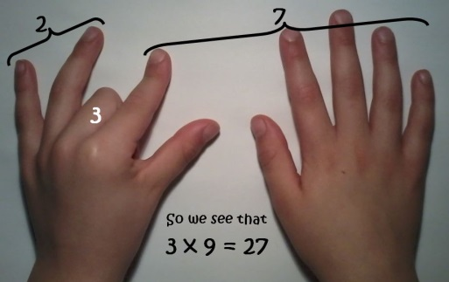  9x  TIPS  Hold out hands with all fingers (and thumbs) stretched out in front of you.  1 x 9 (fold down first finger of left hand and you are left with 9 fingers) = 9  2 x 9 (fold down second finger leaving one finger to the left of the folded finger (this is the tens) and 8 fingers to the right of the folded finger (this is the units) = 18  3 x 9 ((fold down third finger leaving the two fingers to the left of the folded finger (this is the tens) and 7 to the right of the folded finger (this is the units) = 27  The digits of each multiple add up to 9.  1 + 8 = 9  2 + 7 = 9  3 + 6 = 9  Etc  Even 99  9 + 9 = 18 then 1 + 8 = 9  And 108  1 + 0 + 8 = 9
Friday 17th November | 11 x  TIPS  - Spot the patterns, 11,22,33 etc  - Add 10 then 1
Friday 14th November | 12 x  TIPS  - Spot the patterns in the units digit 12, 24,36,48,60  - Add 10 then 2
Friday 1st December | 8 x table  TIPS:  - 8x is the same as doubling (multiplying by 2) then doubling again (x4) and then doubling again (x8)  - 7 x 8 = 56 (double 7 is 14, double 14 is 28, double 28 is 56)  - Double the 4 x table  All answers are even
Friday 8th December | 7 x table (saved the best till last!)  TIPS:  Just have to learn it –keep adding on 7s!

We will be revisiting all the multiplication tables after the Christmas break and again after Easter next year.
Learning multiplication and division facts is achieved through regular practice (with objects, through games and songs, saying it out loud, writing it down, using everyday situations e.g. pairs of children lining up, eggs in boxes etc).
Remember that by learning just one fact you get THREE FREE!
E.g. by knowing that 2 x 4 = 8 you also know that 4 x 2 = 8, 8 ÷ 4 = 2 and 8 ÷ 2 = 4.
I hope you find this information helpful. Please do not hesitate to come and see me if you have any questions.
Regards,

Janine Gray

