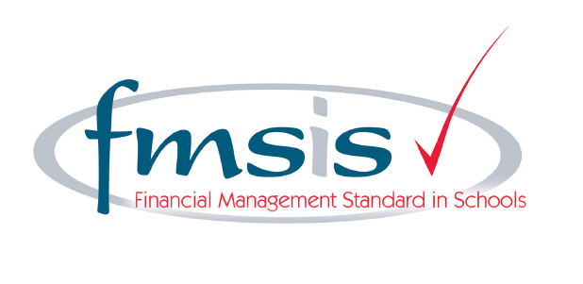
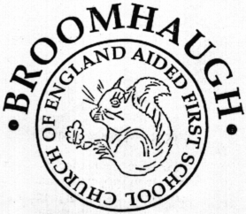 Person Specification
Ms. J. Stephenson
Head teacher Broomhaugh CE Aided First School
Church Lane
Riding Mill
Northumberland
NE44 6DR

/ 01434 682374
 Admin@broomhaugh.northumberland.sch.uk
www.broomhaugh.northumberland.sch.uk

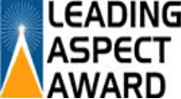

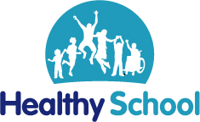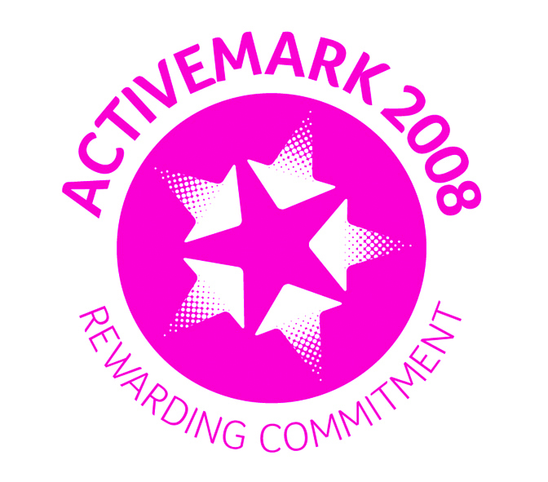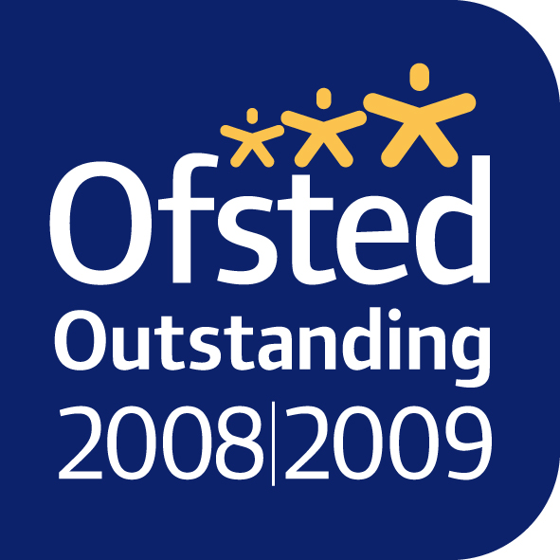

2nd July 2014
Dear Parents

From the beginning of next term, significant changes are happening to school food: cooking is back on the curriculum, every pupil in Reception, Year 1 and 2 will be eligible for free school meals and from January, new food standards are being introduced. These are three of the 16 actions in the School Food Plan, which aims to transform what children eat in schools and how they learn about food (see www.schoolfoodplan.com).
Good food and good food culture has been shown to lead not only to healthier, happier and more fulfilled children, but to improved educational attainment. Evidence from those areas that already provide universal free school meals is that children eat more healthily and perform better academically. Schools in those areas have also reported improved behaviour and atmosphere as a result of all pupils eating together every day.
New standards for school food have recently been published and will come into force in January, however we are on the whole already following these standards. By following them, we can be sure that our pupils will get the nutrition they need across the whole school day.
We believe that the school lunchtime is a great opportunity for all our children to sit down together and enjoy their healthy and tasty meal, while developing their social skills. We therefore hope that all parents will take up this offer of a free school meal for our younger pupils.
As you are aware the majority of children in school eat and love their school dinners !
Our menus are available on the school website and are all nutritionally balanced before they are published.

I hope you will take advantage of this opportunity for your child to enjoy a healthy, balanced and nutritious meal every day.
I wanted to write to you to explain these changes and, importantly, to ask you to fill out the enclosed forms so that where appropriate the school can continue to receive funding through the pupil premium.
We ask that ALL PARENTS fill in the attached school meals registration form
and return to school by MONDAY 14th JULY.

Yours sincerely

