Class 1 Curriculum Information Spring Term 2018
Maths  *number and place value  *mental addition and subtraction/multiplication and division strategies  *problem solving  *geometry  *measurement | 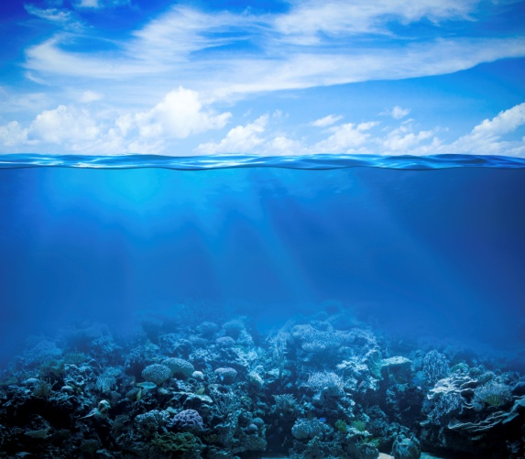  Ocean & Seas | Science/Design Technology  *Use junk modelling to create their own fantasy island  *Investigate the way waves moves.  *Build a boat challenge.  *Carry out floating and sinking experiments, design and construct boats that will carry maximum weight.
English  Poetry: Exploring poems about the Sea by poets like Celia Warren and Author Jeannie Baker for inspiration. Writing their own poems using senses, ensuring punctuation and adjectives are used effectively. Labels, lists, signs and posters; Children use labels, lists, signs and posters to write about sea creatures and The Lonely Sea Monster. They write about their own imaginary creatures and undersea worlds Letters: Reading and Responding to letters including Dear Greenpeace. |  | History/Geography  *Interpret a range of sources of geographical information, including maps, globes and aerial photographs.  * Learn about the seas that surround the UK. Develop knowledge of the oceans and continents of the world.  children will explore retelling the story and discover tales of Grace Darling  *Charles Darwin; Enter the world of famous naturalist Darwin and his discoveries. Research the Galapagos Islands and create a fact-file
Art  *Using bold brush mark techniques to create waves crashing  *Sea collage  *painting seascapes | Computing  *Using Google Earth to explore the Seas around the world  *Children will use a range of information technologies including manipulating images and sounds to retell Grace Darling stories. | PSHE  *Exploring relationships and recognising important people in our lives.  * Children will be thinking about their emotions such as feeling proud and jealous.
RE  *Listen and retell Bible stories including Jesus welcomes the children and miracle stories  *Identify Church symbols and Easter symbols  *Looking at how the Church celebrates Easter | PE  *Dance - theme At the Seaside  *gymnastics ;  - balancing and making shapes  - practising travelling in different ways  - posture and body control | Music  *Explore sounds of the sea on recordings.  *Respond to the music emotionally and use words to describe these emotions.  *Rain, rain, go away;  * Exploring pitch  *Exploring timbre, tempo and dynamics

