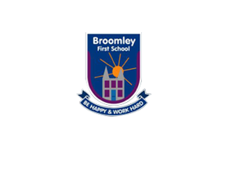

**Special Events / Visits**

* Roald Dahl day (13th September)
* Forest school (every other Friday afternoon)
* A magical visit to Chopwell woods (December)

**RE**

* We will find out that we are Special and unique.
* We will talk about who God is and how Christians believe he created the world.
* We will think about people who love us and help us.

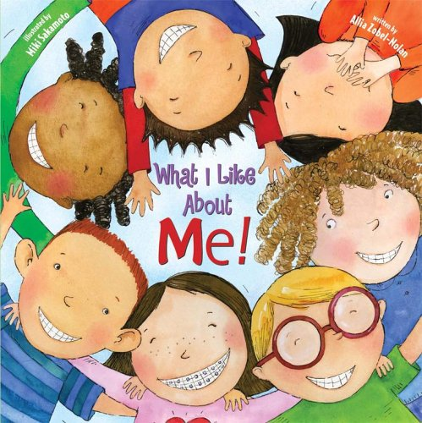 **Creative Curriculum** 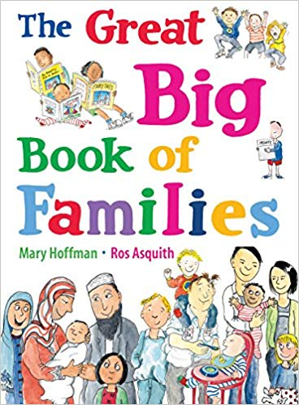

**Reception 2019-2020**

**Autumn Term 1:**

**Marvellous Me!**

**Communication & Language**

**As communicators we will:**

* Answer what , when and where questions about stories and events
* Ask what, when and where questions.
* Follow more than one instruction
* Listen carefully and respond appropriately to what others say
* Tell our own stories and explain events significant to our lives and home.
* Try to solve problems effectively in a positive way Use a range of tenses when communicating.

**Mathematics**

**As mathematicians we will:**

* Continue practising careful counting to 10.
* Secure recognising numbers to 10, ordering numbers and finding one more.
* Begin to solve mathematical problems
* Construct 2D shapes
* Secure our formation of the numbers to 10.
* Sort objects into groups.
* Recognise some times of the day that are relevant to our routine.

**Physical Development**

**As healthy movers we will:**

* Travel with confidence in a range of ways
* Continue to develop our handwriting and form letters and numbers correctly with a range of mark making tools.
* Use one handed tools such as scissors with increased safety and control to cut straight and wavy lines.
* Talk about all the ways we keep fit and healthy and how our body can move.
* Think about using space safely

**Personal, Social & Emotional Development**

**As individuals and friends we will:**

* Play cooperatively, work together and take turns
* Be able to solve problems and negotiate
* Speak confidently in a group and talk about our opinions, feelings and behaviour
* Continue to follow school and class expectations

**Expressive Arts and Design**

**As artists, actors and musicians we will:**

* Act out narratives as a small group
* Represent our own ideas through art, music and dance
* Use a variety of tools and resources purposefully and safely
* Explore and create different textures and colours within art work
* Create, change and talk about sounds made with musical instruments.

**Understanding the world**

**As explorers and investigators we will:**

* Discuss how we can care for each other and ourselves.
* Explore how a range of technological objects work.
* Discuss the range of technology we have at home and at school.
* Begin to solve problems for ourselves.
* Observe seasonal changes in the outdoor environment.

**Literacy**

**As readers and writers we will:**

* Talk to others about books we have read and think about what might happen in books.
* Continue learning new letter sounds.
* To take part in rhyming and rhythmic activities.
* Read simple words.
* Look at books independently. Try to spell words using our phonic knowledge. Begin to write labels.
* Form recognisable letters when using a pencil.
* Be able to read and write our first names.