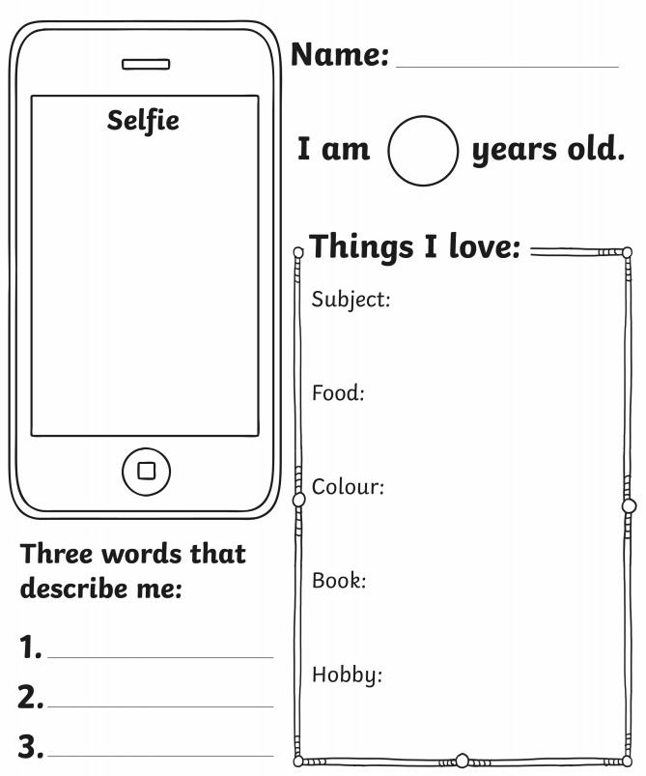
Finally, two things that you do not know about me…
_____________________________________________
_____________________________________________
_____________________________________________

