11th January 2019

Dear parents and children,

Once again, thank you all very much for the hard work and time spent practising the times tables at home. Little and often really is important. Please see dates below for this term.

This information is also available on the school website.

Friday 18th January | 5 x (50 x table for those children very confident with 5 x table)  TIPS:  - If it is an even number x 5 then the answer will have a 0 at the end  - If it is an odd number x 5 then the answer will have a 5 at the end  (Counting in multiples of 50 e.g. 50, 100, 150, 200 and spotting patterns and links with 5x table)
Friday 25th January | 3 x  TIPS:  - Answers go odd, even, odd, even etc
Friday 1st February | 6 x  TIPS  - Double 3x table  - All answers are even
Friday 10th February | 4 x  TIPS:  - 4x is the same as doubling (multiplying by 2) then doubling again  - 7 x 4 = 28 (double 7 is 14, double 14 is 28)  All answers are even
Friday 15th February | 8 x table  TIPS:  - 8x is the same as doubling (multiplying by 2) then doubling again (x4) and then doubling again (x8)  - 7 x 8 = 56 (double 7 is 14, double 14 is 28, double 28 is 56)  - Double the 4 x table  All answers are even
Friday 22nd February | HALF TERM
Friday 1st March | 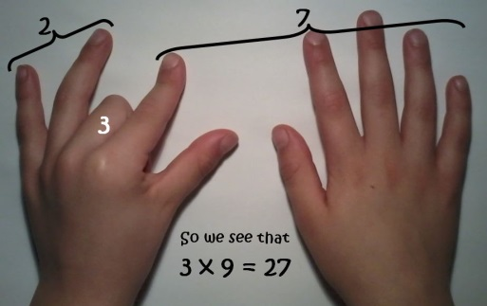  9x  TIPS  Hold out hands with all fingers (and thumbs) stretched out in front of you.  1 x 9 (fold down first finger of left hand and you are left with 9 fingers) = 9  2 x 9 (fold down second finger leaving one finger to the left of the folded finger (this is the tens) and 8 fingers to the right of the folded finger (this is the units) = 18  3 x 9 ((fold down third finger leaving the two fingers to the left of the folded finger (this is the tens) and 7 to the right of the folded finger (this is the units) = 27  The digits of each multiple add up to 9.  1 + 8 = 9  2 + 7 = 9  3 + 6 = 9  Etc  Even 99  9 + 9 = 18 then 1 + 8 = 9  And 108 becomes 1 + 0 + 8 = 9
Friday 8th March | 11 x  TIPS  - Spot the patterns, 11,22,33 etc  Add 10 then 1
Friday 15th March | 12 x  TIPS  - Spot the patterns in the units digit 12, 24,36,48,60  - Add 10 then 2
Friday 22nd March | 7 x table  TIPS:  - keep adding on those 7s
Friday 29th March | Applying multiplication and division facts to problem solving and reasoning
Friday 5th April | Maths Mashup

There are many fantastic games to practise times tables that are available on the internet/apps.

When practising at home the following idea may be helpful. It helps the children to see how in multiplication the numbers can be swapped around. It also reinforces the link between multiplication and division.

Multiplication triangles – write all the number facts for each triangle.
3 x 5 = 15
5 x 3 = 15

15 ÷ 5 = 3
15 ÷ 3 = 5
2 x 5 = 10
5 x 2 = 10

10 ÷ 5 = 2
10 ÷ 5 = 2
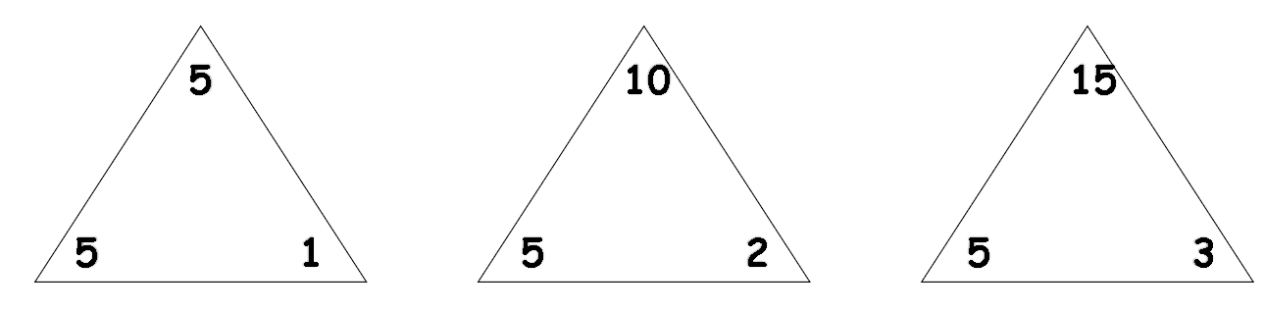

1 x 5 = 5
5 x 1 = 5

5 ÷ 5 = 1
5 ÷ 1 = 5

It also helps children to visualise multiplication as ‘arrays’. This shows how it is repeated addition.

When it is turned around it shows
5 rows of 3 (5 x 3)
This shows 3 rows of 5 (3 x 5)

This then leads to division questions e.g. I have 15 counters/smarties, how many rows of/groups of 5 are there? (15 ÷ 5 = 3). How many rows of/groups of 3 are there? (15 ÷3 = 5)

You may also have heard about a new statutory multiplication tables test that will come into force from June 2020. Schools in England will be required to administer an online multiplication tables check (MTC) to year 4 pupils (this will directly affect our current year 3 children). The national curriculum specifies that pupils should be taught to recall the multiplication tables up to and incuding 12 × 12 by the end of year 4.

I hope you find this information helpful. Please do not hesitate to come and see me if you have any questions.
Regards,

Janine Gray

