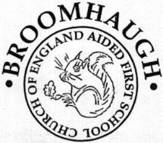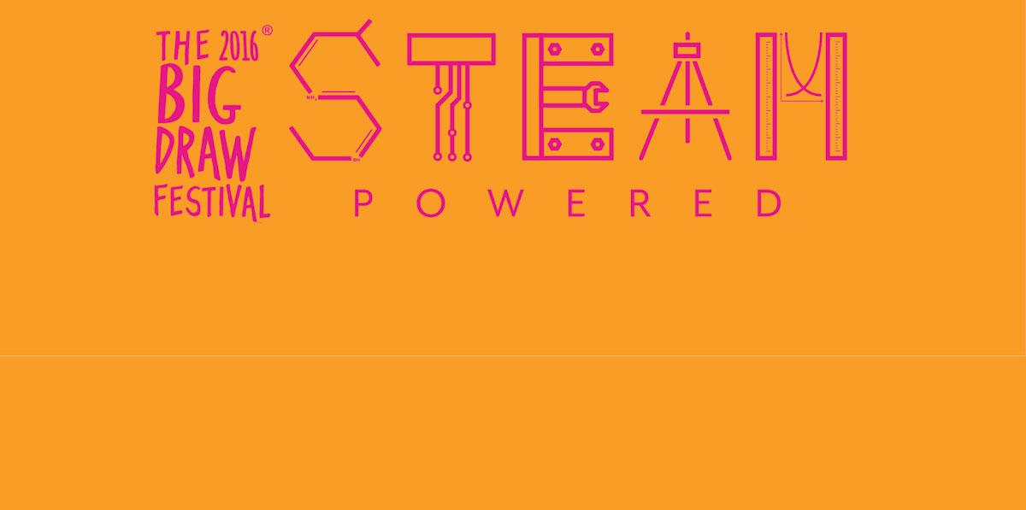

During October we will be celebrating the Big Draw at Broomhaugh CE First School. This year’s theme encourages us all to recognise the importance of drawing in

**S**cience, **T**echnology, **E**ngineering, **A**rt and **M**aths (STEAM) and to promote visual literacy in schools across all subjects. Each week the children will have the opportunity to engage in at least two cross-curricular drawing activities.