Class 1 Curriculum Information Summer Term 2017
English  *Quest stories; Children read a range of quest stories, exploring structure and language choice. They explore 4 types of sentence and experiment with tense. Children write their own extended stories  *Information texts (mini beasts)  *Classic poems; Children listen to and explore a piece of challenging classic poetry. They discuss what the poem is about and how the whole poem makes them feel. They then paint a picture of a tree which reflects the feelings generated by the poem.  Spelling, grammar and punctuation;  *Children to continue to practise and develop a wide range of punctuation.  *Children using their spellings in their writing. | 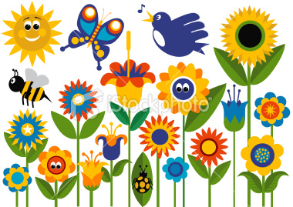  In the Garden | Art  *exploring natural landscape for artistic inspiration.  *to know how art and design reflects and shapes our history  *Background of local art  *create sculpture/3D works inspired by nature  *landscapes
Music
*Exploring timbre, tempo and dynamics.
*Sounds interesting- exploring sounds.
*Using instruments- sounds found in the garden.

History/Geography  History of the local area; explore local area looking out for clues about the past.  Look at old photographs of area, speak to local resident, compare Riding Mill to 100 years ago.  *Seasonal and daily weather patterns in the UK  *Weather experts; Through a series of lively activities, such as creating and filming their own weather forecasts or making their own weather station, build knowledge of seasonal and daily weather patterns in the UK. Begin to understand the hot and cold areas of the world as well as developing locational knowledge and early geographical skills.  *Study of geography of school/grounds and key human and physical features of surrounding environment | Science/Design Technology  Life cycles - butterfly, frog, chicken  Children study and discuss the various minibeasts to be found in the locality. They identify and categorise each one, looking at insects, spiders, worms and so on.  Plants; Children build upon their knowledge of plants and growing. Learn what plants need to grow, why our natural spaces are important and visit a local allotment.  Design and create small world gardens!  - Learn why plants disperse their seeds and the various clever ways in which they do this. | RE  *Saints and Followers- Understanding what it means to be a saint and learning about prominent saints.  *Baptism – Understanding the role of baptism and what it entails.
Computing  Computer science - Human Crane based on garden themed story book  Information technology - paint garden from the story, collect data from school wild area and local park and graph,  - Digital Learning - digital-literacy.org.uk - follow the digital trail lesson - digital footprints they leave behind | PE  Games - ball skills, tackling/defending, understanding rules  Athletics - running, jumping, throwing, awareness and development of body actions  Dance - theme - life cycles | PSHE - Aims to...  *equip children with an understanding of different types of change, positive and negative, and common human responses to it  *develop children's ability to understand and manage the feelings associated with change.

