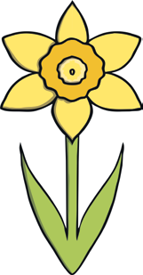
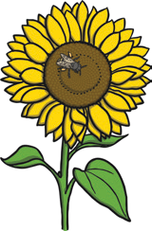
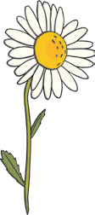
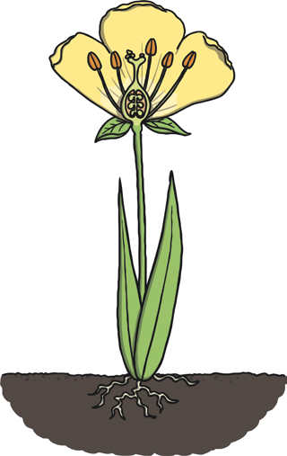Science Assessment Year 1: Plants Answers

question | answer | marks | notes
1. Label the parts of the plant.
 | flower  leaf | 4 | 1 mark for every correctly labelled part.
 | roots
 | stem
2. Can you name any of these flowers?
 | rose  daffodil  sunflower  daisy | 4 | 1 mark for every correctly labelled flower.
3. Sort these leaves into two groups
 |  | 2 | 1 mark for the correct sorting of  the leaves.
 | A correct explanation of sorting due to  leaf shape. |  | 1 mark for the  correct explanation.

4. For these foods, which part of the plant they come from is eaten?
 |  |  |  | 6 | 1 mark for every correct answer.
5. Complete the following table.
 | Takes in the water |  |  | 3 | 1 mark for every  correct answer.
 | from the soil and
 | keeps the plant in
 | the ground.
 | Collects sunlight.
 | Helps to support
 | the plant and
 | carry water to
 | different parts of
 | the plant.
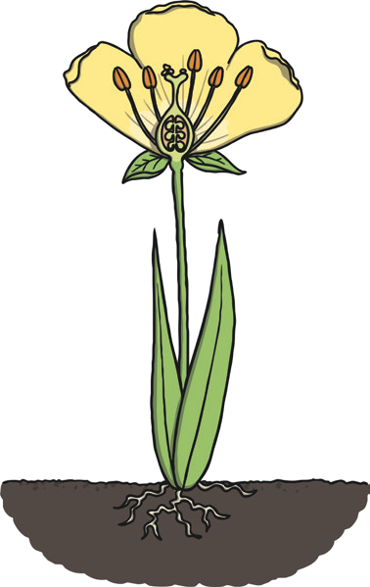
roots | stem | leaves
carrot | celery | lettuce
flower | fruit | seed
broccoli | tomato | sweetcorn

6. Which of these trees is evergreen? How do you know?
 | The explanation should include keeping its leaves all year around.  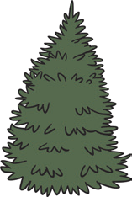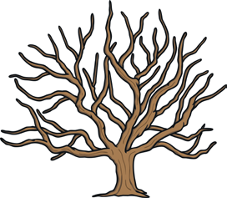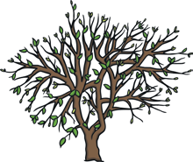 | 2 | 1 mark for the correctly circled tree.  1 mark for the  correct explanation.
7. Circle the part of the plant that a bee is attracted to?
 | stem flower roots leaves | 1
8. Labels the parts of the tree.
 | fruit trunk branch  leaf  root | 5 | 1 mark for the correct answer.
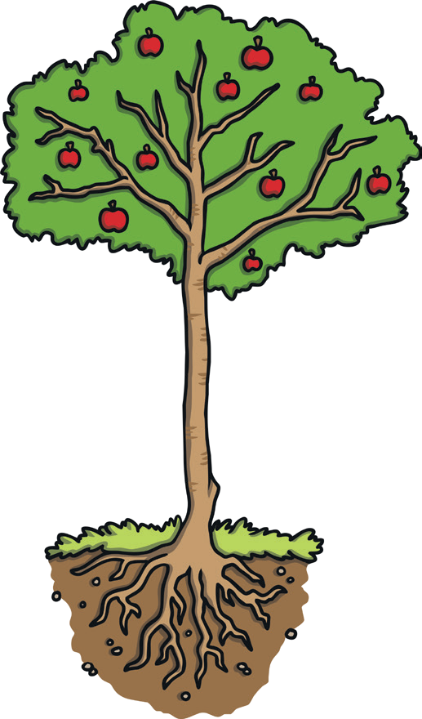

9. What will this tree look like in winter? Draw it in the box.
 | 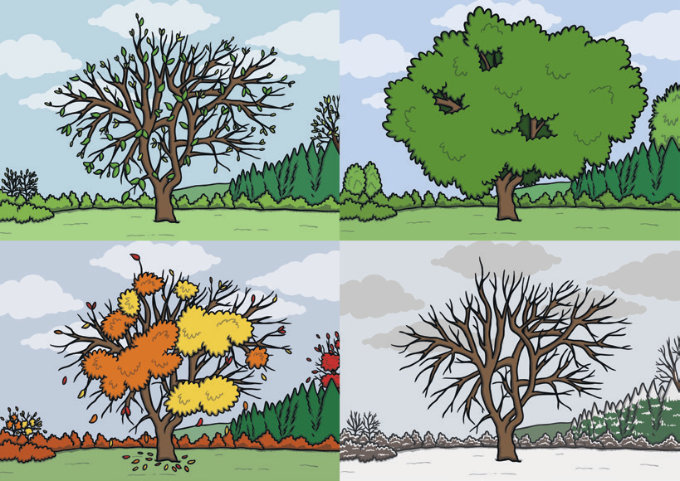 | 1 | Accept any suitable  winter tree drawing.
10. What does a plant need to survive? Write down two things.
 | Please accept any answers from the following:  water warmth food sunlight | 2 | 1 mark for every correct answer.

