Class 1 Curriculum Information Autumn Term 2018
Maths  see separate sheet | 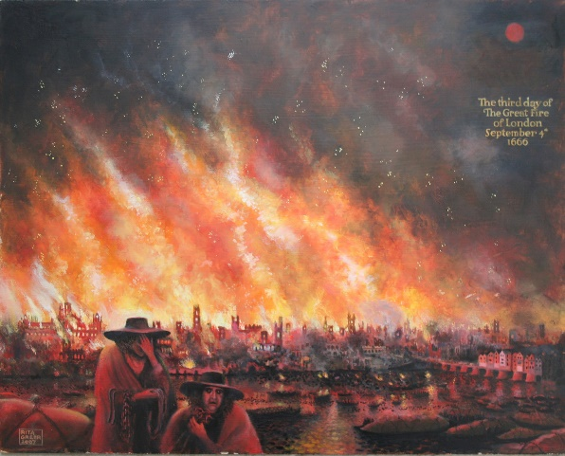  The Great Fire of London | Art  *Make 2D collages of Tudor homes, and re-enact the Great Fire of London with tissue paper 'flames'!  *Develop your ideas about this famous cathedral using drawing, imagination and communication  * use charcoal drawing and potato printing to develop artistic ideas inspired by St Paul’s before designing, making and decorating a final model Cathedral.
English
Stories in familiar settings
* writing sentences for different purposes: statements, questions and exclamations. Include speech in narratives and create their version of a well-known story and perform it.
Instructions
*Based on The Great Fire of London – Bakery Children write step by step instruction to make their own bread.
Silly poems
*Use extended noun phrases and know that there are different sorts of sentences that writers use for different effects.
Stories involving fantasy:
* learn about the features of fantasy stories. Write and word process a fantasy story for a class book.
Recounts
*Write recounts based on their knowledge of what it would be like to be a child for the day when the Great Fire of London broke out.
List Poems
*Read, learn, recite, write and perform their own list poems
RE
*God & Creation - give children the opportunity to develop their perceptions and understanding of God, providing opportunity for reflection on feelings of awe, wonder, delight and mystery in relation to the natural world.
*Harvest –raise awareness that we harvest food all around the world and that we usually have plenty but others do not. To discuss what our response as Christians should be to the need of others. Non-Christian faith link Look at stories from other faiths.
*Christmas Gifts & Gift Bringers- deepen children’s understanding of the true meaning of Christmas by exploring the concept of Jesus as a gift;
discuss the thoughts and feelings associated with giving and receiving gifts.
Science/Design Technology  Observe a block of ice and record the changes. Devise an investigation to melt the ice quickly or slowly. Investigate the absorbency of fabrics and explore changes in wax through batik art and crayon making. Record shadow length over time. Set up rain gauges to observe rainfall. Consider the design of buildings, the properties of building materials and the contrast between the materials used in modern buildings and around the time of the Great Fire of London. Make 3D models. Cooking- Make Bread. | Computing  Programme the Beebot around London buildings avoiding the fire. Create and Debug simple programs. Explain how an Algorithm works. Use technology to purposefully create, the story and create images of scenes from The Great Fire of London. Use Technology safely and respectfully, Recognise common uses of information technology beyond school – Practise Logging in to desktops familiarising with keeping personal information safe. | PSHE  New Beginnings; The theme offers children the opportunity to see themselves as valued individuals within a community, and to contribute to shaping a welcoming, safe and fair learning community for all. Throughout the theme, children explore feelings of happiness and excitement, sadness, anxiety and fearfulness, while learning (and putting into practice) shared models for ‘calming down’ and ‘problem solving’.
History/Geography  *Contrast fire-safety from the past with today. Role-play key people at the time of the 1666 Great Fire. Learn about the food eaten at the time and contrast the diet of the rich and poor. Study the buildings of the period and create your own buildings. Study the rhymes and songs of the time Become tour guides and teach visitors about this historic event.  *Create informative maps of 17th Century London  *Prepare a tour guide speech to inform visitors to 17th Century London about the key places that were involved in the Great Fire.  *Seasonal Changes | PE  Gymnastics -  * balance on beams, jumping and landing, forward rolls, travelling in different ways from point A to B  Games  *jumping, skipping and bouncing  *developing bat and ball games  Tennis/Yoga and Year 2 swimming | Music  The Long and Short of it; children learn to distinguish between long and short sounds and use them to create interesting sequences. They will play percussion instruments with control and sensitivity, paying attention to dynamics and pitch. They record their sequences using symbols.  Feel the Pulse; children develop the ability to recognise the difference between beat and rhythm and to perform with a sense of beat.

Year 1 Maths Overview

Autumn
wk |  | Ruth Houghton |  | Cassie Reed
 | Number and Place Value | Counting, reading and writing numbers up to 20  Counting forwards and backwards to 100  Identify the number that is '1 more' as the next number when counting | Geometry | Recognise, name and describe 2D shapes - squares, triangles, circles and rectangles  Recognise basic line symmetry  Sort 2D shapes according to their properties using Venn and Carroll diagrams
3/4 | Addition and Subtraction | Read, write and understand symbols +,- and =  Know pairs of numbers that make 5, 7, 10  Answer missing number calculations eg. 3 + _ = 5 | Geometry  Geometry | Describe position and direction using common words (including half turns, whole turn, quarter turn and three quarter turn)
5/6 | Addition and Subtraction | Double small numbers  Identify the number that is '1 less' - relate to calculations such as 16 - 1= | Measurement | Recall days of the week, months of the year and seasons.
7/8 | Number and Place Value | Read and write numbers and number-names to 20  Compare and order numbers to 20  Identify 1 more and 1 less  Estimate sets of objects, count to check and order sets according to size  Understand 0 | Measurement | Know the value of different coins and values (up to £2)  Use different coins to show different values and amounts.  Begin to make amounts in pence.  Know teen numbers as some tens and some ones.
9/10 | Number and Place Value | Understand and then make teen numbers (10 and some 1s)  Compare and order numbers to 20, then 30 | Measurement | Compare lengths and heights  Estimate, compare and measure lengths using uniform standard and non-standard units.

Year 2 Maths Overview

Autumn
wk |  | Ruth Houghton |  | Cassie Reed
1/2 | Number and Place Value | Estimate and count a number of objects up to 100  Locate numbers on 0−100 beaded lines and 1−100 squares  Read and write numbers to 100 in numbers and words  Compare pairs of numbers and find a number in between  Order three numbers, order 2-digit numbers | Geometry | Sort 2D shapes according to symmetry properties using Venn diagrams  Identify right angles and sort shapes using Venn diagrams  Recognise squares, rectangles, circles, triangles, ovals and hexagons Investigate which tessellate  Sort shapes and objects using a two-way Carroll diagram
3/4 | Addition and Subtraction | Revise number bonds to 6, 7, 8, 9 and know bonds to 10  Learn related subtraction facts.  Know multiple of 10 bonds to 100 eg. 20 + 80 = 100  Learn bonds to 20  Rehearse number bonds to 10 and 20 using stories | Geometry | Understand and use terms and vocabulary associated with position, direction and movement.
5/6 | Addition and Subtraction | Double numbers to double 15  Use patterns in number bonds  Use number bonds to solve more difficult additions, to subtract and to solve additions bridging 10 | Multiplication and Division | Count in 2s, 5s and 10s from zero  Count in multiples of 2p, 5p and 10p  Number sequences of 2s, 5s and 10s  Find the totals of coins and ways to make an amount  Use coins to make given amounts of money
7/8 | Number and Place Value | Begin to mark numbers on a landmarked line  Compare and order numbers, using < and > signs  Work systematically to find all possible inequalities  Find 1 and 10 more or less using the 100-square  Find 10 more and 10 less than any 2-digit number | Number and Place Value | Know and use ordinal numbers  Understand that 2-digit numbers are made from some 10s and some 1s Understand place value using 10p and 1p coins  Find and record all possible amounts using 10p and 1p coins  Find 10p more and 10p less
9/10 | Addition and Subtraction | Add and subtract 10, 20 and 30 to any 2-digit number  Add and subtract 11, 21, 12 and 22 to any 2-digit number  Solve addition and subtractions by counting on and back in 10s then in 1's. Add and subtract 2 digit numbers.  Solve addition and subtraction problems using concrete and pictorial representations | Measurement | Measure lengths using uniform units  Begin to measure in centimetres and metres

