Literacy challenges  Week beginning 8.6.20  This week our literacy challenges are based on the story, ‘The Princess and the Wizard.’  You can begin by listening to the story. We’ve suggested these follow up activities to consolidate a range of reading and writing skills previously taught in school.  https://youtu.be/x8wPFHlua_A | Monday – What is your favourite setting?  Read or listen to the story. A setting is where the story takes place. This story has many setting because of the different ways she tries to escape. What was your favourite? Draw the setting and label it or better still, why don’t you make a model of it?  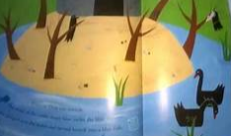 | Tuesday – Wizarding words!  The wizard is trying to steal real words for his new book so we need your help!  Using all letters of the alpabet – Make two piles of letters (a pile consonant and a pile of vowels.) Take a consonant, then a vowel before taking a final consonant. Now read the word you’ve created. If it is a real word write it in the air with your magic wand so the wizard can’t see it. If it is nonsense, write it on piece of paper to fool the wizard!
Write it Wednesday  Write the following sentences on paper and read it together using different voices (shouting, angry, whisper, singing, laughing, sad, etc) Track the words with your finger as you read.  I will find you said the wizard  I will get out of here said the princess  Words in red as an extension if children are confident!  Cover a word and ask them to write the word that is missing. Repeat with other words. Read the sentence together then hide it completely. Now ask them to write it on their own! Repeat with sentences of your own. | Thursday – Write a list of 7  The Princess was celebrating her 7th Birthday  Throughout the day write as many different lists that include 7 things …. This could be 7 friends, 7 animals, 7 sweets! Be as imaginative as possible!  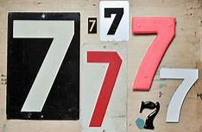 | Friday – Write a colour poem  Think of your favourite colour and the different things around you that match. Use the stem sentence ….  As ……… as a ………  For example,  As blue as the sea.  As white as snow.  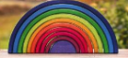  Why don’t you illustrate your work and send it to school so we can add it to our display in the class!

