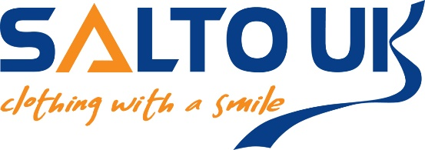

Dear Parent/Carer

Firstly, and most importantly, we hope you are all safe and well and looking after each other. We would like to update you on our plans to ensure you are able to receive the school uniform required for when the children return to school.
Please see below the ways you can order. As the situation changes, we will notify you via our Facebook page and on our website, so please check in now and again to stay updated.

ONLINE
We are currently processing all uniform orders from our website www.saltouk.com
When you order online, you will have 2 delivery options:
- Home delivery - where your child can try for size at home and this gives you time to exchange if required. We will endeavour to process and dispatch orders as quickly as possible, but as we are working with a smaller team, please allow extra time for delivery.
- Free ‘collect from store’ option - your order will be processed and will be available from our collection point in Prudhoe as soon as non-essential shops can open once again – hopefully, early June.
Exchanges can be made by contacting us via email or Facebook and we will have your preferred size ready to exchange once our collection point is open. Any items that are returned are dated and hung untouched for 48 hours before they are returned to stock.

BY POST
If you do not want to buy online, please contact us via email and we will provide an order form for you to print, complete and post/deliver to our shop in Prudhoe. Orders cannot be processed unless full payment is enclosed.

SHOP
We will open our ‘collection point’ as soon as non-essential shops can reopen, as we will be able to adhere to the social distancing measures through a queuing system outside our shop. However, we will only open our main shop when we feel it is safe for you, your child and our staff, as we must provide a risk-free, Covid secure environment. We expect that children will not be able to try communal clothes on due to the risk of cross contamination, therefore we are encouraging everyone to order online as the ‘try before you buy’ in our shop may not be an option.

QUERIES
We will add measuring videos on our Facebook page and our website to help you make the correct choice. If you have any queries please contact us via our Facebook page or email us at enquiries@saltouk.com

GUARANTEED UNIFORM FOR SEPTEMBER
We urge you to order as soon as possible as it will allow you time to exchange if necessary. When our shop does reopen, we will be observing strict rules in accordance with the Health and Safety Executive, therefore queues may be likely as we expect only 2 customers (plus one child per adult) in at a time.

As you know, this situation is ever changing, and we are monitoring it daily. We are committed to keeping our loyal customers updated and providing the best service we can under difficult circumstances, so please remember, as your local supplier, we are here for you.

Take care and stay safe

Team Salto

