April 2017

Dear parents and children,
Once again, thank you all very much for the hard work and time spent practising the times tables at home. As we approach the summer term and our third phase of times tables quizzes, it is even more important that the children should be able to readily recall multiplication facts. Please see dates below for this term.
This information is also available on the school website.
Friday 28th April | 2 x  - If your child is very confident with this then I will be asking them to use their knowledge to answer the 20 x table using the same patterns observed in the 2 x table e.g.  3 x 2 = 6 ► 3 x 20 = 60
Friday 5th May | 5 x (50 x table for those children very confident with 5 x table)  TIPS:  - If it is an even number x 5 then the answer will have a 0 at the end  - If it is an odd number x 5 then the answer will have a 5 at the end
Friday 12th May | 3 x  TIPS:  Answers go odd, even, odd, even etc
Friday 19th May | 6 x  TIPS  - Double 3x table  - All answers are even
Friday 26th May | 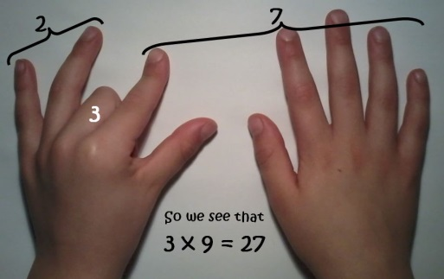  9x  TIPS  Hold out hands with all fingers (and thumbs) stretched out in front of you.  1 x 9 (fold down first finger of left hand and you are left with 9 fingers) = 9  2 x 9 (fold down second finger leaving one finger to the left of the folded finger (this is the tens) and 8 fingers to the right of the folded finger (this is the units) = 18  3 x 9 ((fold down third finger leaving the two fingers to the left of the folded finger (this is the tens) and 7 to the right of the folded finger (this is the units) = 27  The digits of each multiple add up to 9.  1 + 8 = 9  2 + 7 = 9  3 + 6 = 9  Etc  Even 99  9 + 9 = 18 then 1 + 8 = 9  And 108  1 + 0 + 8 = 9
HALF TERM | If you have time over half-term please could you work out how many weeks and days it is until we break up for the summer holidays! You might like to work out how many hours it is! And if you really want a challenge, how many minutes….!!
Friday 9th June | 4 x  TIPS:  - 4x is the same as doubling (multiplying by 2) then doubling again  - 7 x 4 = 28 (double 7 is 14, double 14 is 28)  All answers are even
Friday 16th June | 8 x table  TIPS:  - 8x is the same as doubling (multiplying by 2) then doubling again (x4) and then doubling again (x8)  - 7 x 8 = 56 (double 7 is 14, double 14 is 28, double 28 is 56)  - Double the 4 x table  - All answers are even
Friday 23rd June | 7 x  TIPS:  Just have to learn it!
Friday 10th June | 11 x  TIPS  - Spot the patterns, 11,22,33 etc  - Add 10 then 1
Friday 7th July | 12 x  TIPS  - Spot the patterns in the units digit 12, 24,36,48,60  - Add 10 then 2

There are many fantastic games to practise times tables that are available on the internet/apps. If children log on to their School360 accounts >tools>IR (Interactive Resources) they will find many multiplication/division activities and games.

I hope you find this information helpful. Please do not hesitate to come and see me if you have any questions.
Regards,
Janine Gray
