Class 1 Curriculum Information Autumn Term 2019
Maths - Number:  Place value  Y1 - numbers to 20  Y2 - Numbers to 100  Addition and Subtraction  Y1 - Numbers within 20 (including money)  Y2 - Numbers within 100 (including money)  Y1 - Place value to 50 and multiplication  Y2 - Multiplication  *examples found online at ‘White Rose’ maths | 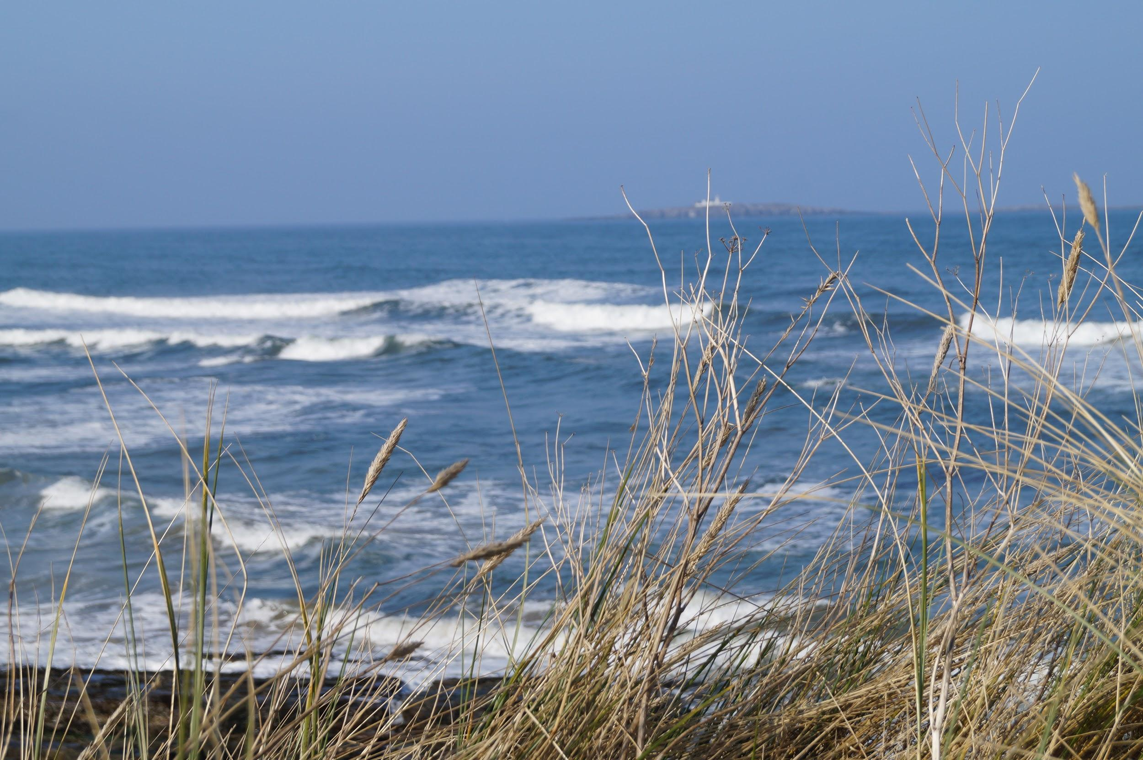  Oceans and Seas | Art  Using bold brush mark techniques to create waves crashing  Sea collage  Painting seascapes in the style of J.W. Turner
Design Technology
Design and create an under the ocean world to present to the class.
Build a boat challenge – carry out floating and sinking experiments.
English  Stories in familiar settings – The Whales Song by Dylan Sheldon and Gary Blythe  Tales from a Variety of Cultures – The Dragon Machine by Helen Ward  Information texts – Mister Seahorse by Eric Carle and a variety of non-fiction  Poems on the theme of the sea Where The Forest Meets the Sea by Jeannie Baker and a variety of poems on the theme. |  | RE
 | Music  Music tuition from Northumberland County Council Music Service – the recorder. | PSHE  TEAM – Together Everyone Achieves More  To learn about the benefits of the different groups or teams they belong to. How to listen, being kind, recognise when people are being unkind to them, celebrate strengths and differences, making good choices.
Science  Living Things and their Habitats: Identify a range of common animals including fish, amphibians, reptiles, birds and mammals.  Explore how the animals in the Atlantic demonstrate adaptation to their environment through camouflage and an ability to repel water.  To understand what ocean food chains are using scientific language to describe elements within them.  Seasonal Changes: Explore the 4 seasons, the sun and shadows. | Geography  Learn about the seas that surround the UK.  Develop knowledge of the oceans and continents of the world. Investigate how waves are caused and how they move.  Investigate the Galapagos Islands. | Computing  Using Google Earth to explore the Seas around the world  Children will use a range of information technologies including manipulating images and sounds to retell Grace Darling stories.
 | History  Learn about:  Charles Darwin  Grace Darling | PE  Magpie Sports  Gymnastics
Dear Parents,
We hope you have enjoyed the summer with your children and that you are all now ready for the new school year. Thank you for your end of school year gifts, it was very generous and thoughtful of you all.
Please find information enclosed, about the work that we will be covering this term. Our topic for the Autumn term is Ocean and Seas. This will be an interesting topic full of creative learning opportunities in all the curriculum areas.
We would very much appreciate parental help with the following throughout the term:

*Reading with/to your child for 15 minutes every day/and or encouraging them to read independently if they are a fluent reader. It may take a few days to sort out reading books for all the children while we settle in. We appreciate your input if a book is not suitably matched to your child's reading level at this early stage. Please make a note in the reading scrapbook and we can change the book quickly.

*Daily spelling practice of the weekly spellings. (Year 1 will be given spellings to practise after the half term break, to give them a chance to settle into the new expectations of Class 1, Year 2 spellings will start in week 2.) These will continue to be given out every Monday and the children will be given a spelling 'quiz' on the following Monday.
Please note learning the spellings doesn’t have to be simply writing the word over and over on the piece of paper given. We encourage learning new spellings through games, play, art and more. Examples of activities you can do at home may be painting the words, chalking the spellings outside, using a timer to see how many times they can write the spelling in 1 minute, writing the word in sand, making play dough letters to spell the word, using letter fridge magnets etc. Any fun method that works for your child that you can both enjoy and complete.

This term we are focusing again mainly on the words children use frequently in their writing. Although these words can seem easy when they practise them at home, it is common for children to forget how to spell them when their creativity is flowing as they write. It is beneficial therefore to keep returning to these words.

School 360
During this term, your children will be given a username and password to access School 360 which is a learning platform subscribed to by Northumberland County Council that offers a huge bank of learning resources for your child to gain access to at home via a computer and at school. There are a variety of educational games that allow them to enhance their learning on subjects such as Maths, English, Science and more. Information on this to follow.

Timetable reminders:
A PE kit will be required on a Tuesday and Thursday. This should include a white t shirt, dark blue/black shorts or tracksuit bottoms and PE shoes. This should be left in school as we may have impromptu PE lessons at any time.
Please ensure your child has outdoor PE shoes as we will be outside for some of the lessons. Year 2 will no longer have swimming lessons. Swimming will now start in Year 3.

Playtimes:
Please make sure that your child wears suitable clothing and footwear for outdoor play …we go out in all weathers…rain, hail, snow or shine!
Please do not hesitate to contact us if you have any questions.

Yours sincerely,
Cassie Reed, Ruth Houghton, Sarah Curtis, Amanda Cave and Helen Hunter

