12th January 2018

Dear parents and children,
Once again, thank you all very much for the hard work and time spent practising the times tables at home. Little and often really is important. Please see dates below for this term. As it is a very short term I have focused on some of the key times tables.
This information is also available on the school website.
Friday 19th January | 5 x (50 x table for those children very confident with 5 x table)  TIPS:  - If it is an even number x 5 then the answer will have a 0 at the end  - If it is an odd number x 5 then the answer will have a 5 at the end  (Counting in multiples of 50 e.g. 50, 100, 150, 200 and spotting patterns and links with 5x table)
Friday 26th January | 3 x  TIPS:  - Answers go odd, even, odd, even etc
Friday 2nd February | 6 x  TIPS  - Double 3x table  - All answers are even
Friday 9th February | 4 x  TIPS:  - 4x is the same as doubling (multiplying by 2) then doubling again  - 7 x 4 = 28 (double 7 is 14, double 14 is 28)  All answers are even
Friday 16th February | HALF TERM – please practise well 8x table after half term
Friday 23rd February | 8 x table  TIPS:  - 8x is the same as doubling (multiplying by 2) then doubling again (x4) and then doubling again (x8)  - 7 x 8 = 56 (double 7 is 14, double 14 is 28, double 28 is 56)  - Double the 4 x table  All answers are even
Friday 2nd March | 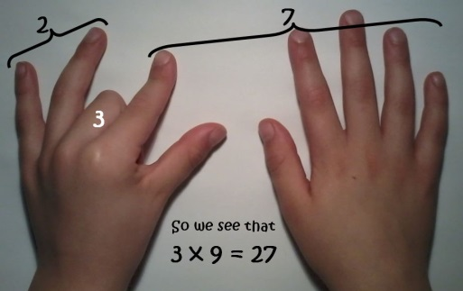  9x  TIPS  Hold out hands with all fingers (and thumbs) stretched out in front of you.  1 x 9 (fold down first finger of left hand and you are left with 9 fingers) = 9  2 x 9 (fold down second finger leaving one finger to the left of the folded finger (this is the tens) and 8 fingers to the right of the folded finger (this is the units) = 18  3 x 9 ((fold down third finger leaving the two fingers to the left of the folded finger (this is the tens) and 7 to the right of the folded finger (this is the units) = 27  The digits of each multiple add up to 9.  1 + 8 = 9  2 + 7 = 9  3 + 6 = 9  Etc  Even 99  9 + 9 = 18 then 1 + 8 = 9  And 108 becomes 1 + 0 + 8 = 9
Friday 9th March | 11 x  TIPS  - Spot the patterns, 11,22,33 etc  - Add 10 then 1
Friday 16th March | 12 x  TIPS  - Spot the patterns in the units digit 12, 24,36,48,60  - Add 10 then 2
Friday 23rd March | 7 x table  TIPS:  keep adding on those 7s
Friday 30th March | GOOD FRIDAY

There are many fantastic games to practise times tables that are available on the internet/apps.
I hope you find this information helpful. Please do not hesitate to come and see me if you have any questions.
Regards,

Janine Gray

