Wednesday 11th January 2017
Dear Parents,
Welcome back after the Christmas holiday and happy new year to all. We would like to say a big thank you for all the lovely cards and gifts we received!

Please find information enclosed, about the work that we will be covering this term. Our topic for the Spring term is AFRICA. This will be an interesting topic full of creative learning opportunities in all the curriculum areas and will include an enrichment activity visit (details to follow).

We would very much appreciate parental help with the following throughout the term:

*Reading with/to your child for 15 minutes every day/and or encouraging them to read independently if they are a fluent reader. Thank you for your contributions to the Reading Scrap books. These are checked by a member of staff daily so please feel free to use them as a home/school communication tool for any issues you may have or if you need to arrange an appointment to see a teacher.

*Daily spelling practice of the weekly spellings. These will continue to be given out every Monday and will be collected in the following Monday.
Please help your child to use the following method at home:
LOOK at the word
SAY the word
COVER the word
WRITE the word keeping the spelling covered
CHECK against the spelling
The main focus of spelling is usually words that are used frequently in their writing. Although these words can seem easy when they practise them at home, it is common for children to forget how to spell them when their creativity is flowing as they write. It is beneficial therefore to keep returning to these words.
*for information on practising maths at home please refer to the separate sheet.

Timetable reminders:
PE will take place on a Tuesday and Friday for Year 1 and just on a Tuesday for Year 2. The PE kit should include a white t shirt, dark blue/black shorts or tracksuit bottoms and PE shoes.
Please ensure your child has outdoor PE shoes as we will be outside for some of the lessons. SWIMMING for Year 2 is on Friday afternoon.

Playtimes:
Please make sure that your child wears suitable clothing and footwear for outdoor play …we go out in most weathers…rain, hail, snow or shine!

Please do not hesitate to contact us if you have any questions.

Yours sincerely,
Ruth Houghton, Clare Laidler, Sarah Curtis, Amanda Cave and Hayley Gullon

Class 1 Curriculum Information Spring Term 2017
Maths  *number and place value  *mental addition and subtraction/multiplication and division strategies  *problem solving  *geometry  *measurement  *geometry  *statistics  (see help at home sheet for more detailed information) | 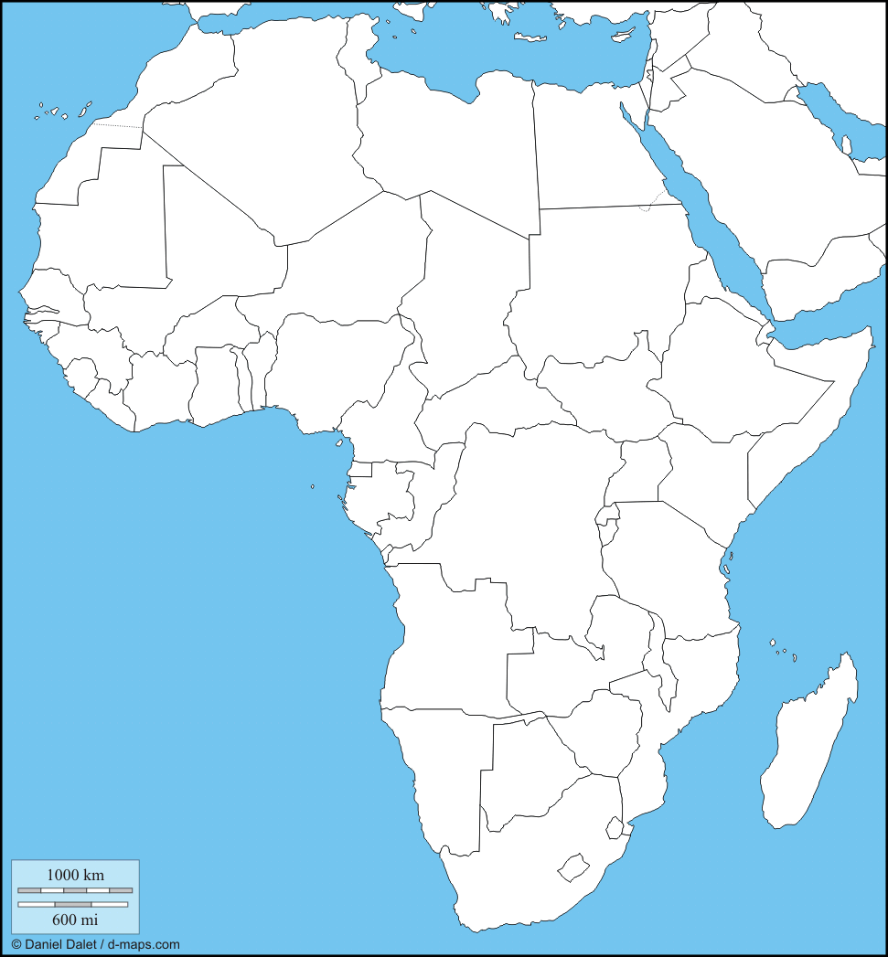  AFRICA | Science/Design Technology  Y1- Identify and name a variety of common animals  Including fish, amphibians, reptiles, birds and mammals  identify and name a variety of common animals that are carnivores, herbivores and omnivores  Y2- Describe how animals obtain their food from plants and other animals, using the idea of a simple food chain, and identify and name different sources of food  Y1&Y2- Design and structure a suitable habitat for animals around the world- exploring and testing what materials are appropriate for survival.
English  Traditional Tales; Children will learn to tell some traditional tales including African and tales from other cultures. They will 'experience' stories through role play, story sacks and other creative strategies. They will retell tales in their own words and eventually write their own tales using traditional language with a beginning, build up, problem that is solved and an end.  Poetry;  Children will be able to recite poems orally and recognise and join in with predictable phrases and rhymes. Chn will create their own animal poems focusing on using adjectives and punctuation within their poems. |  | History/Geography  *Learn about Nelson Mandela using books and computer sources  *comparison of local area to small village in Africa  *use geographical vocabulary such as season, equator, savannah  *use of map, globe, atlas to discover Africa and the UK's place in the world  *weather related fieldwork
Art  * To develop ideas and opinions on a variety of African Art.  * To explore the use of colour and silhouette.  * To understand the use of printed pattern in African art and recreate the printing processes.  * To learn African techniques such as Batik.  * To plan and create their own African art showpiece. | Computing  *Computer Science: understanding algorithms. Use of range of programs to give directions - make the elephant reach the water, give directions to hippo's house  *Information Technology: 2paint, publish, create a story, music toolkit, story creator, ipad camera/video recorder  *Digital Literacy: learn how to use technology safely through 'Me online ks1' | PSHE  'Going for Goals'  *knowing our own strengths  *setting realistic goals  *breaking down goals into realistic steps  *working towards the reward of a finished task  *making choices and giving reasons  *evaluating success
RE  Children will look at the topic “Jesus, friend to everyone” which will consist of listening and retelling miracle stories from the Bible.  Begin to be able to make the connection between the Bible stories and Christian belief.  Be able to describe briefly how the Church celebrates Easter and the symbols of Easter. | PE  Dance; Creating sequence of actions and still body shapes to the theme of 'Animals'  Gymnastics; Combination of floor and apparatus work involving travelling, balancing and holding body shapes.  Games; ball skills | Music  *Kye Kye Kule Ghanaian song.  *exploring pulse and rhythm  * Drums, clapping beats and keeping rhythm.
Plan: Abacus Year 1

Spring - Mrs Houghton
Wk | Strands | Weekly Summary
1  2 | Number and place value  Mental addition and subtraction | Say the number one more or less and two more or less using a number line or a 100 grid  2 digit numbers - count forwards and backwards from a given number, read and write 2 digit numbers, say if numbers are more than, less than or equal to
3  4 | Mental addition and subtraction Problem solving, reasoning and algebra  Mental multiplication and division | use number facts to solve simple addition and subtraction word problems  Missing number problems e.g. 5 + _ = 12  Double numbers - relate to x 2  Share and group small amounts
5  6 | Fractions | Recognise, find and name half an object/shape/amount
7  8 | Fractions | Recognise, find and name quarter of an object/shape/amount
9  10 | Mental addition and subtraction (MAS) | Add a 1-digit number by counting on from a 2-digit number,  Subtract a 1-digit number by counting back
11  12 | Number and place value  Multiplication and division | Use arrays to multiply  Solve problems using multiplication and division  Find 2 digit numbers on a bead string/ 100 grid. Know that 2 digit numbers are some tens and some ones
Spring – Mrs Laidler
Wk | Strands | Weekly Summary
1  2 | Measurement | Pre-topic assessment  To compare, describe and solve problems for length and height (mm, cm, m)
3  4 | Measurement | To measure and begin to record mass/weight (g and Kg).  To know and use words relating to dates and time.
5  6 | Measurement | To measure and begin to record time (hours, minutes, seconds)  To compare, describe and solve problems for mass or weight.
7  8 | Geometry | To recognise and name 2d shapes.  To recognise and name 3d shapes.
9  10 | Geometry | To describe position.  To describe direction and understand North, East, South, West.
11  12 | Geometry | To describe movement and turns including whole turn, half turn and three-quarter turn.

 | Plan: Year 2
Spring - Mrs Houghton
Wk |  | Strands | Weekly Summary
1  2 |  | Number and place value  Mental addition and subtraction | Use place value for additions and subtractions;  add and begin to subtract 9, 10 and 11
3  4 |  | Mental addition and subtraction Problem solving, reasoning and algebra | Find the difference between 2 numbers  Find change from 10p and 20p, and from £10 to £20  Solve problems involving addition and subtraction
5  6 |  | Mental addition and subtraction Problem solving, reasoning and algebra | Add two 2-digit numbers by counting on  Calculate multiplication and division statement  Solve problems involving multiplication and division
7  8 |  | Mental multiplication and division  Problem solving, reasoning and algebra | Count in 2s, 5s and 10s to solve multiplication problems  Record the 2, 5 and 10 times-table with corresponding division facts  Investigate multiplications with the same answer  Write multiplications and divisions to go with arrays,  Rotate arrays
9  10 |  | Mental multiplication and division  Problem solving, reasoning and algebra | Recognise, find, name and write fractions1/3, 1/4, 2/4 and 3/4 of a length, a shape, an amount, a set of objects
11  12 |  | Measurement  Number and place value Problem solving, reasoning and algebra  Mental addition and subtraction | Recognise all coins, know their value, and use them to make amounts;  Recognise £5, £10, £20 notes;  Write amounts using £.p notation; order coins 1p – £2 and notes £5 – £20; Add several coins writing totals in £.p notation  Add two amounts of pence, using counting on in 10s and 1s;  Add two amounts of money, beginning to cross into £s
Spring – Mrs Laidler
Wk |  | Strands | Weekly Summary
1  2 |  | Statistics | Pre-Topic Assessment  To interpret and construct simple pictograms.
3  4 |  | Measurement | To compare and sequence intervals of time.
5  6 |  | Measurement | To tell the time to the hour, half hour and quarter hour and draw the hands on a clock face to show these times.
7  8 |  | Geometry | To describe the properties of 2D shapes.
9  10 |  | Geometry | To identify and understand vertical lines of symmetry in 2D shapes.

